**SYSTEM STUDY**

1. IDEA BEHIND THIS SOFTWARE

* The basic idea behind this is to make the software at the run time by providing abstraction to user i.e. user doesn’t know, how the thing are really happening.
* Firstly this is not a single program. this software consist two programs :
  + Finalproject
  + Project
* Finalproject gets the data from the user and makes an interface that implement the information given by the user i.e. finalproject ask you some question just like your interest area and the password and username you prefer and other information and then on the basis of this it will generate a folder that contain some file and a software.
* Project programs is the program that uses the information that generated by the finalproject and provide abstraction to user.
* So basically we are not generating software at run time but we provide an abstraction of this.

2. UNDERSTANDING THE SOFTWARE (EXTERNAL LEVEL)

**2.1 FIRST STEP TOWARDS UNDERSTANDING OF OUR SOFTWARE**

* Firstly we have to understand the flow the information into the computer.
  + User input the data.
  + Computer process it.
  + And in the last it generate the result.

For eg:-The flow of the data in the computer, when we add no.

USER INPUT

**6**

**7**

**3+6**

**2+4**

**3,6**

**3,4**

**2,4**

**9**

**3+4**

PROCESS

OUTPUT

**25**

**10+15**

**10,15**

* 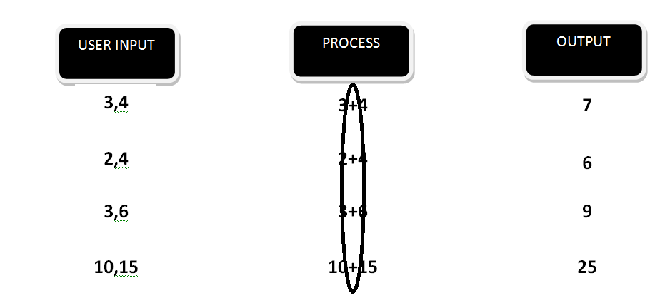You can clearly see that we can have different type of input and output based on that but in this we found a similarity, that data can of different type but the processing will be same every time. You can relate this with the second stage of understanding our software.

**2.2 SECOND STEP TOWARDS THE UNDERSTANDING OF OUR SOFTWARE:**

* First our project asks you the project name and the database name.

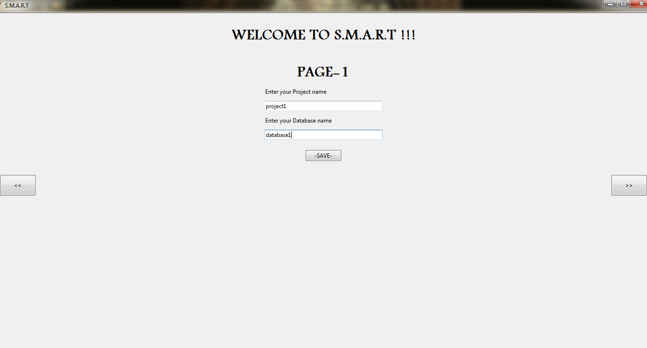

* Second it will ask you to choose your area of interest.

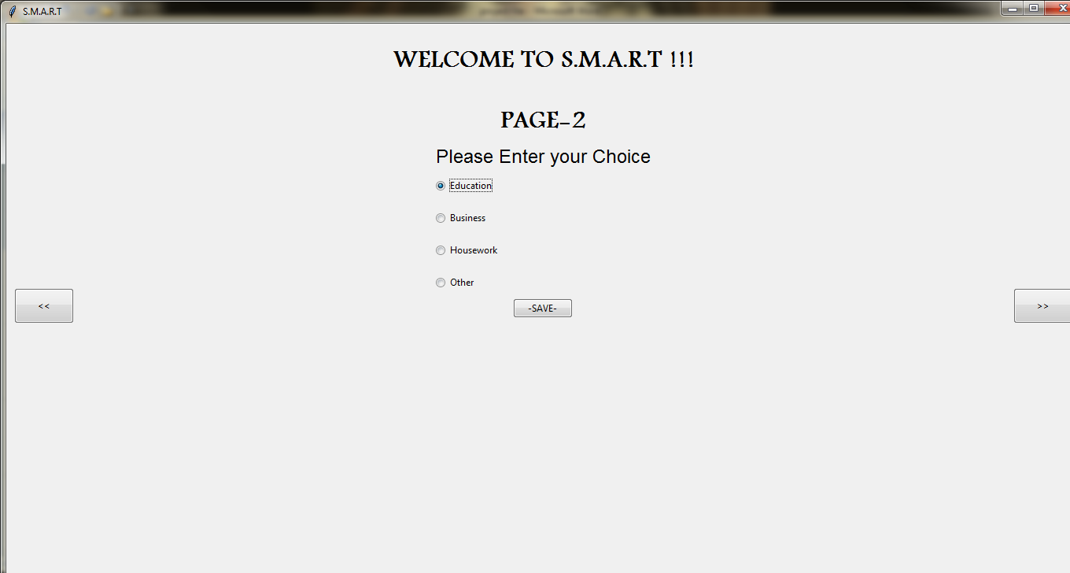

* After this it will ask you to give the entry name that you want(pre-entered entry name is required )to include in our program. (entry is the just like the name ,address and other information that you want from the user .)

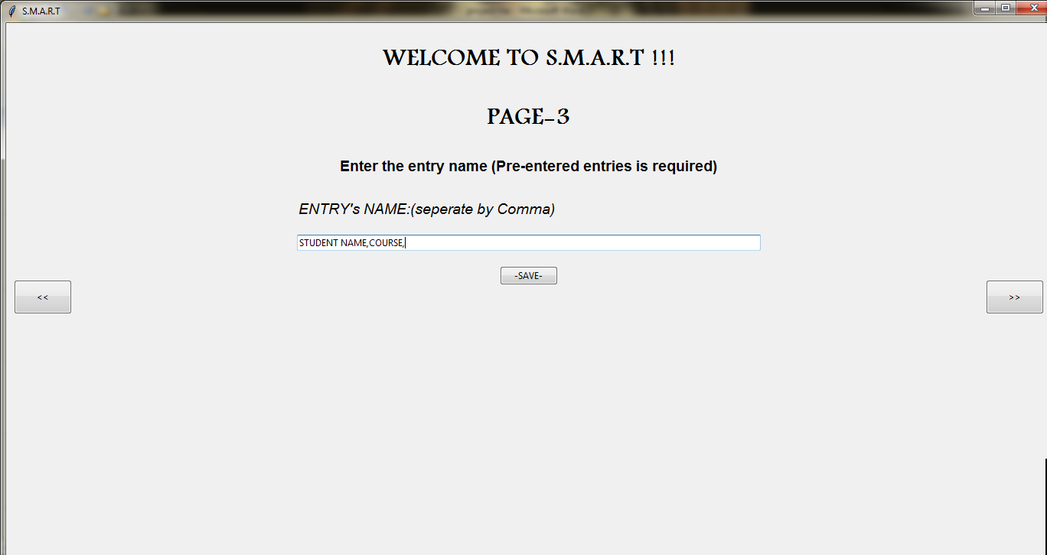A

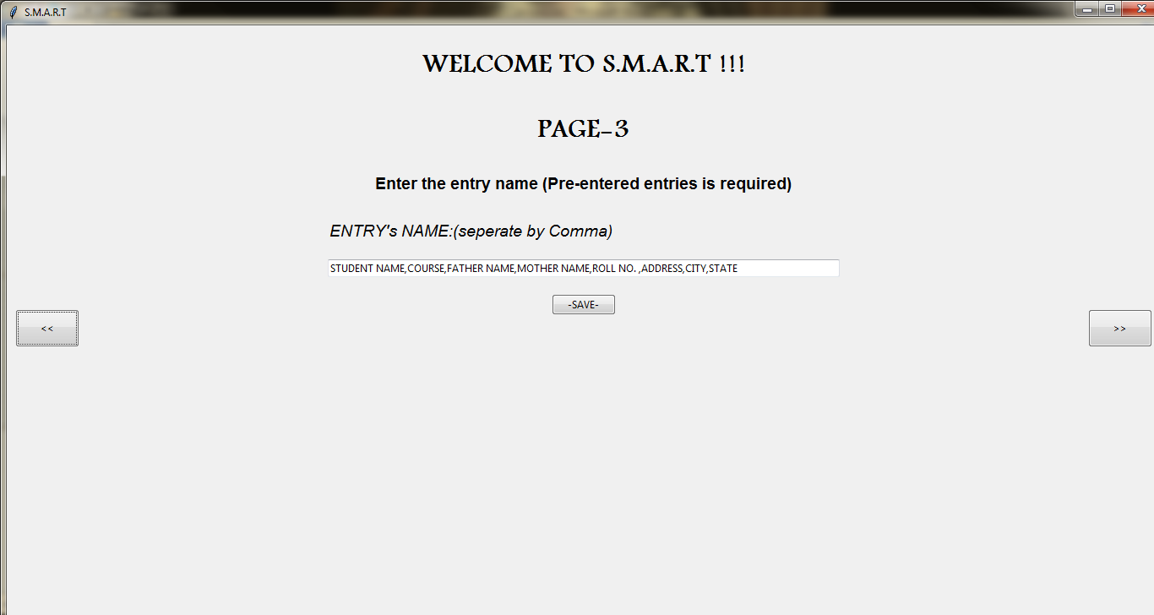

* After it will ask you to enter the username and password.(that are going to be your username and password in your program.)

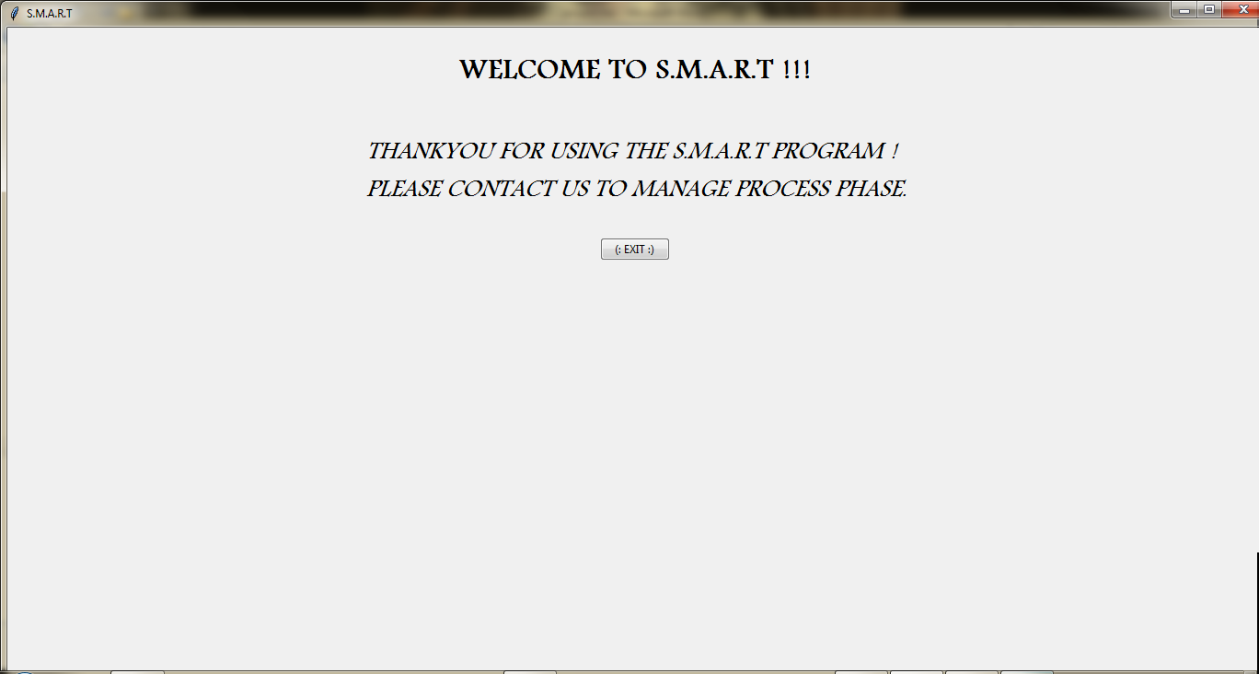

* Now you can relate the things that we have tell you that we have different input and output but same processing ie. We can create software with the different entry name for each software and accept the data from the user but the software will perform task regarding to your interest area that may be EDUCATION, HOUSEWORK AND OTHERS.

At this point we have understood the designing goal and external working of this software. Now let understand it’s feasibility study.

3. FEASIBILITY STUDY

**3.1 WHAT IS FEASIBILITY STUDY?**

A feasibility study is defined as an evaluation or analysis of the potential impact of a proposed project.

OR

“A feasibility study can be defined as a controlled process for identifying problems and opportunity, determining objective, describing situations, defining successful outcomes, and assessing the range of costs and benefits associated with several alternatives for solving a problem.”-**centre for Entrepreneurship at university of Rochester**

**3.2 TYPES OF FEASIBILITY STUDY**

* **TECHNICAL FEASIBILITY**
* **OPERATIONAL FEASIBILITY**
* **ECONOMIC FEASIBILITY**

**TECHNICAL FEASIBILITY REGARDING OUR SOFTWARE**

Technical feasibility is concerned with specifying equipment (hardware & software) that support our software system.

* First you have python language installed on your system to run the program.
* Second you must have the MySql server installed on your system (with MySql shell or MySql workbench ).
* You must have the Python Mysql connector installed to perform the task on the database from our Program.

**OPERATIONAL FEASIBILITY REGARDING OUR SOFTWARE**

Operational feasibility is related to the human, organization or political aspects.

* You should know about the python language and to execute the sql command from the python program.
* You will not have to do any special changes in your system to work on this software except installation of the MySQL server.

**ECONOMIC FEASIBILITY REGARDING OUR SOFTWARE**

Economic analysis is the most frequently used technique for evaluating the effectiveness of proposed system. It is economic feasibile because all the building components of the software(python language ,Mysql server ,Python-MySql connector) are free.

**SYSTEM ANALYSIS**

**1.FUNCTION & MODULES USED IN THE SOFTWARE**

**1.1 Modules imported in the program**

In this section we discussed about the modules used in the making of this software:-

* **Tkinter:-** This module has used to make the GUI of the software .
* **Ttk:-** ttk is the sub module of the tkinter module, it is also used in the making of GUI component such as Buttons, Labels, Frames etc.
* **Os:-** Os module is used in the making of the directory structure of the program.
* **Shutil:-** Shutil is the module that actually help to copy and delete the file and folder.
* **Csv(Dictreader & Dictwriter):-** this module helps to handling of the csv(Comma Separated Values) file.ie, reading or writing or updating the csv file.
* **Functools:-** Actually we need the partial function of the functools module to send the argument with the function in the button’s command statement.

**1.2 Functions that implement in the program**

We already know that this software is consists of two programs.

Finalpro+Project

First we will discuss the function implement in the finalpro programs-

* **Action():-**this function is used by the ” << “ and ” >>” button to navigate the user from one page to other page.
* **Action1():**- this function is used by the “ next>> ” of the page1.It actually pack the page2.
* **Action2():**-this function is used by the “next>>” of the pages2.It packs the page3 with implementing some logic for the program.
* **Action3():**-this function is used by the “next>>” of the pages3.It packs the page4only.
* **Action4():-** this is the main function that actually do the task of creation the desired software. In phase-, the directory structure is created. In phase-2, the database is created and in the phase-3,the data given by the user is written into the various file.
* And then rest of the portion of the program is contain the logic for the GUI and creating different frames and buttons, combobox,entry box etc.

Second we will discuss the function implement in the Project programs-

* **Action():-**  this function fills the different treeview (table that show the data Fetched from the database) with the data fetched from the database.
* **Action6():-** this program helps to print the data of the treeview in the excel sheet.
* **Page():-** page function is used by the menu item to navigate the user form one frame/page to other frame/page.
* **Action1():-** Is used by the submit button of the home page.
* **Action2():-** Is used by the edit page.
* **Action3():-**is used by the money deposit of the Deposit page.
* **Security():-**is used to authenticate the user it checks for the username and the password given by the user.

**2.FUNTIONAL REQUIREMENT**

**2.1 HARDWARE SPECIFICATION**

Hardware is a set of physical components, which performs the functions of applying appropriate, predefined instructions. In other words, one can sy that electronic and mechanical parts of computer constitute hardware.

* PROCESSOR AND MEMORY:- For run the software smoothly, you should have at least Pentium-II processor and 2gb of ram .
* HARD DISK SPACE:- the hard disk drive for the database should be at least of the capacity 100gb. But it is recommended to have one of capacity 500 gb.
* MOUSE:-A mouse is must for the user running under Windows OS or any other graphical environment.
* KEYWOARD:-Each user must have a 104 key extended keyboard.

**2.2 SOFTWARE SPECIFICATION**

The software is a set of procedures of coded information or a program which when fed into the computer Hardware, enables the computer to perform the various tasks.

* MySql server:- It must be installed in the user’s system to manage the database.
* MySql python connector:- It must be installed in the user’s system to connect the program to the software.

**SYSTEM DESIGN**

**3.1 DATA FLOW DIAGRAM(DFD)**

* **DFD FOR “HOME” OF MENU ITEM**

3.ADD DATA TO DATABASE.

**USER**

NO

YES

NO

YES

4.CREATE NEW ENTRY

4.ADD IT OT DATABASE.

4.SHOW ERROR

4.ADD MONEY TO EXIST RETAILER ACCOUNT

YES

NO

YES

NO

**DFD OF THE HOME PAGE**

* **DFD FOR “EDIT” OF MENU ITEM**

**USER**

NO

**DFD OF THE EDIT PAGE**

YES

4.CHANGE THE DATA IN THE DATABASE

4.SHOW ERROR

* **DFD FOR “VIEW” OF MENU ITEM**

**DFD OF THE VIEW PAGE**

**USER**

4. SHOWING THE DATA IN THE TABLE

3.FETCH THE DATA FROM THE DATABASE.

* **DFD FOR “DEPOSIT” OF MENU ITEM**

**USER**

YES

NO

YES

YES

NO

4.SHOW ERROR

NO

YES

NO

3.FIRST USER HAVE TO MAKE THEIR OWN PAYMENT FIELD

4. SUBTRACT THE AMOUNT FROM THE FEE AMOUNT AND SHOW THE EXTRA MONEY IF ANY.

4.SUBTRACT THE AMOUNT FROM THE FEE AMOUNT AND SHOW THE EXTRA MONEY IF ANY.

**DFD OF THE DEPOSIT PAGE**

4.SHOW MESSAGE

**3.2 ENTITY RELATIONSHIP (ER) DIAGRAM**

There are total three entities in this software but user can implement one at a time and their attribute will also be decided by the user at run time so we cannot have an entity diagram with the fix no. of attribute.

**Student/home_budget/other**

******************************************************************************************************

**SOURCE CODE**

******************************************************************************************************

**SYSTEM TESTING**

During testing, the program to be tested is executed with a set of test cases, and the output of the program for the test cases is evaluated to determine if the program is performing as expected. Due to its approach, dynamic testing can only ascertain the presence of errors in the program. Testing forms the first step in determining the errors in a program. Clearly, the success of testing in revealing errors in programs depends critically on the test cases.

**top down and bottom-up approaches**

Generally, parts of the program are tested before testing the entire program. Besides, partitioning the problem of testing, another reason for testing parts separately is that if a test case detects an error in a large program, it will be extremely difficult to pinpoint the source of the error.

The bottom-up approach starts from the bottom of the hierarchy. First, the modules at the very bottom, which have no subordinates, are tested. Then thee modules are combined with highest-level modules for testing. To perform bottom-up testing, drivers are needed to set up the appropriate environment and invoke the module. It is the job of the driver to invoke the module under testing with the different set of test cases.

The top-down testing is advantageous, if major flaws occur toward the top of the hierarchy, while bottom-up is advantageous if the major flaws occur toward the bottom.

If is often best to select the testing method of conform with the development method. Thus, if the system is developed in a top-down manner, top-down testing should be used, and if the system is developed in a bottom-up manner, a bottom—up testing strategy should be used.

**TYPES OF TESTING**

**1. Unit Testing**

It focuses on smallest unit of software design. In this we test an individual unit or group of inter related units.It is often done by programmer by using sample input and observing its corresponding outputs.  
Example:

a) In a program we are checking if loop, method or

function is working fine

b) Misunderstood or incorrect, arithmetic precedence.

c) Incorrect initialization

**2. Integration Testing**

The objective is to take unit tested components and build a program structure that has been dictated by design.Integration testing is testing in which a group of components are combined to produce output.

Integration testing is of four types: (i) Top down (ii) Bottom up (iii) Sandwich (iv) Big-Bang  
Example

(a) Black Box testing:- It is used for validation.

In this we ignores internal working mechanism and

focuses on **what is the output?**.

(b) White Box testing:- It is used for verification.

In this we focus on internal mechanism i.e.

**how the output is achieved?**

**3. Regression Testing**

Every time new module is added leads to changes in program. This type of testing make sure that whole component works properly even after adding components to the complete program.  
Example

In school record suppose we have module staff, students

and finance combining these modules and checking if on

integration these module works fine is regression testing

**4. Smoke Testing**

This test is done to make sure that software under testing is ready or stable for further testing  
It is called smoke test as testing initial pass is done to check if it did not catch the fire or smoked in the initial switch on.  
Example:

If project has 2 modules so before going to module

make sure that module 1 works properly

**5. Alpha Testing**

This is a type of validation testing.It is a type of *acceptance testing*which is done before the product is released to customers. It is typically done by QA people.  
Example:

When software testing is performed internally within

the organization

**6. Beta Testing**

The beta test is conducted at one or more customer sites by the end-user of the software. This version is released for the limited number of users for testing in real time environment  
Example:

When software testing is performed for the limited

number of people

**7. System Testing**

In this software is tested such that it works fine for different operating system.It is covered under the black box testing technique. In this we just focus on required input and output without focusing on internal working.  
In this we have security testing, recovery testing , stress testing and performance testing  
Example:

This include functional as well as non functional

testing

**8. Stress Testing**

In this we gives unfavorable conditions to the system and check how they perform in those condition.  
Example:

(a) Test cases that require maximum memory or other

resources are executed

(b) Test cases that may cause thrashing in a virtual

operating system

(c) Test cases that may cause excessive disk requirement